Mrs. Cooks’ Smart Cookies
Week of May 4-8, 2020
Newsletter & Important Dates
Everyday: | Use your BEST handwriting! Make sure your name is on your homework!  Remember, daily homework is practice that will help you remember what you have learned! Read 20 minutes, record onto Reading Log. Complete all homework and turn in homework book on Friday. Check folder for additional Math or Language Arts worksheets. A homework menu is in your child’s binder.

circle | cylinder | ELA-Shapes  Math-  Plane Shapes  Solid Shapes  Congruent and similar Shapes  Patterns  Science-  Solids, Liquids, Gases  Sink or Float  Changing States of Matter  Washing Hands  Social Studies-  13 Colonies  US Symbols  Local and State Government  Branches of Government | 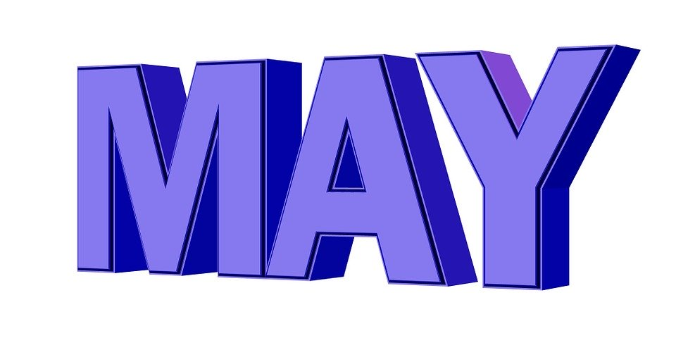  Please have your child practice 20min of reading/math each evening & send in headphones if he or she doesn’t have them    May 8th-last day of assigned lessons  May 22nd- last day to submit lessons    Olivier-May 1  Layla-May 13  Ivye-May 16
square | cube
triangle | pyramid
rectangle | rectangular prism
cone | sphere
Complete Spelling City Lessons
Use Brainpopjr. math, language arts, science and social studies

